**UK Gender Pay Report 2023 - The Barden Corporation (UK) Ltd**

The Barden Corporation is required by law to publish an annual gender pay gap report.

This is its report for the snapshot date of 5th April 2022.

**What are the underlying causes of The Barden Corporation’s gender pay gap?**

The Barden Corporation has a clear policy of paying employees equally for the same and equivalent work, reviews pay and benefits at regular intervals and evaluates job roles and pay grades to ensure a fair structure.

We are confident that the clear published gender pay gap does not stem from paying men and women differently for the same, or equivalent, work. Rather its gender pay gap is a result of the roles in which men and women work within Barden and the salaries that these roles attract.

The mean Gender Pay Gap for 2022 has remained at 23% due to the following reasons:

* We had a higher number of male employees leave the business, as a result of a restructure within our support functions, at a more senior level.
* Due to the lack of female candidates within our demographic area, specialised engineering recruitment has been dominated by males and the majority of candidates for the lower paid, Assembly area, have been female. In addition to this, the more technical shopfloor roles have been filled by males due to the lack of skills set within the Plymouth manufacturing area. We are therefore reviewing what we can do to train, upskill and develop our female colleagues to be more capable of moving into these more technical roles.
* In line with the strategic business direction in 2021/2022, which targeted significant sales growth within the next 5 years, the recruitment drives were focussed on more technical roles to support this plan. As mentioned above, females moving into STEM subjects in school and higher education is still demographically lower, hence the lack of suitable candidates in the labour pool.

**What is the Barden Corporation doing to address its gender pay gap?**

The Barden Corporation recognise that we need to continue to encourage more females into the business which has predominantly been a male dominated environment historically. We will continue to actively promote the business within schools, colleges, universities and at career events, to encourage more females into manufacturing across all levels.

By the very nature of Barden’s business being manufacturing, which mainly attracts male workers into higher skilled jobs due to the lack of females having the same skill sets, women continue to fill our lower skilled, more junior roles.

The annual performance bonus was paid in June 2021, showing 100% of men were awarded as opposed to 95% females is due to a higher male headcount than the snapshot date of 5th April 2022.

**Pay difference between women and men**:

All Barden Corporation (UK) Ltd employees at 05.04.2022

23.4%

The mean gender pay gap is:

16.2%

The median gender pay gap is:

39.56%%

%%%%%

The mean gender bonus gap is:

The median gender bonus gap is:

21.91%

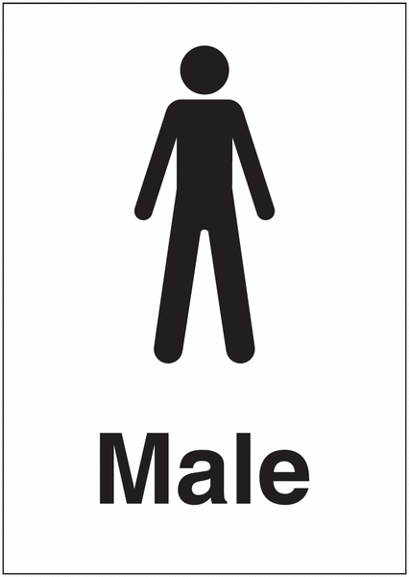Proportion of UK employees receiving a bonus:

In the 12 months preceding 05.04.2022 100% 95.87%

Pay quartiles by gender:

All Barden Corporation (UK) Ltd employees at 05.04.2022

Male

Includes all employees whose standard hourly rate places them at or below the lower quartile.

**BAND A**

Male

*The figures set out above have been calculated using the standard methodologies used in the Equality Act 2010 (Gender Pay Gap information)*

*Regulations 2017.*

I, Martin Knight, Managing Director, confirm that the information contained in this statement is accurate.

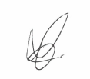

SIGNED: DATE: 03/04/2023